A Guide to Resizing Your Images

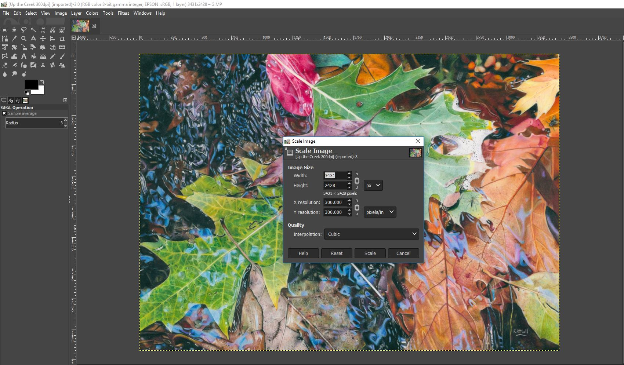

Karen Hull © 2019
Contents

Microsoft Picture Manager – Page 3
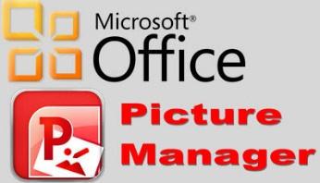

Photoshop – Page 10
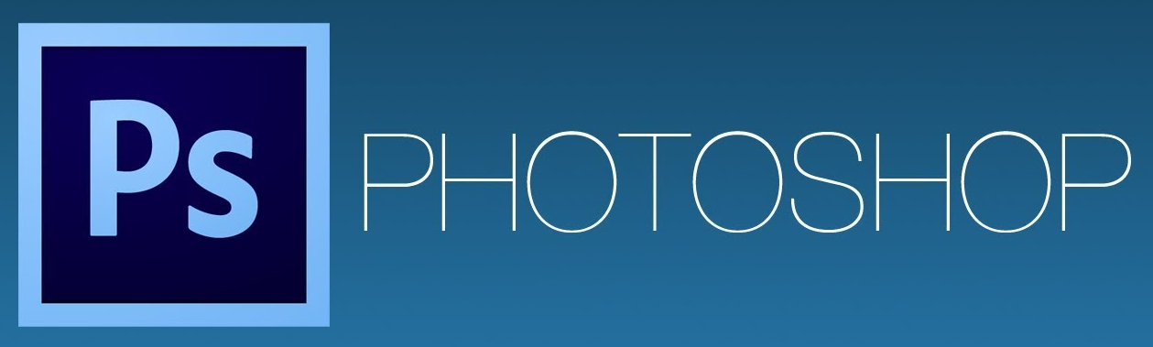

Paint.net – Page 20
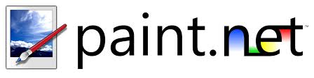

Gimp – Page 26
Preparing Your Images – Page 29

This PDF has been put together based on the information available to me at the time of publication. If you would like to provide information that could update or enhance this document, then please feel free to get in touch.
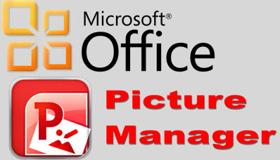

Microsoft Picture Manager is a program that comes as part of the Microsoft Office Suite. If you’re not sure whether you have this program on your PC, type ‘picture manager’ in the search box at the bottom of your screen and the app should appear on the menu for you to click on. Open the app and save it to your desk top.
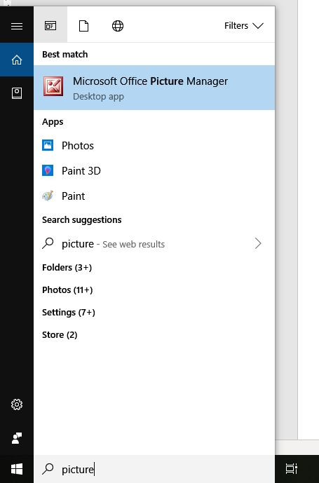
Figure 1

It can be confusing trying to locate the picture you need to edit from within the Picture Manager program and so it is better to locate your image on your computer and then right click on the thumbnail of your image. When you do that, the following menu should come up (Figure 2).

Click on ‘Open with’ and a new menu will come up with all the programs that can edit images on your PC. Hopefully you will see Microsoft Office with a red icon in the menu and when you click on this, your image should open within the Picture Manager app.

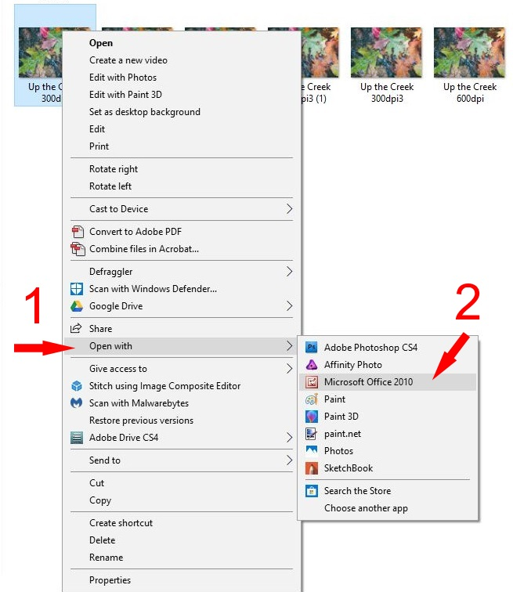
Figure 2

When you open the image in Microsoft Picture Manager, your screen should look something like the following image (Figure 3).

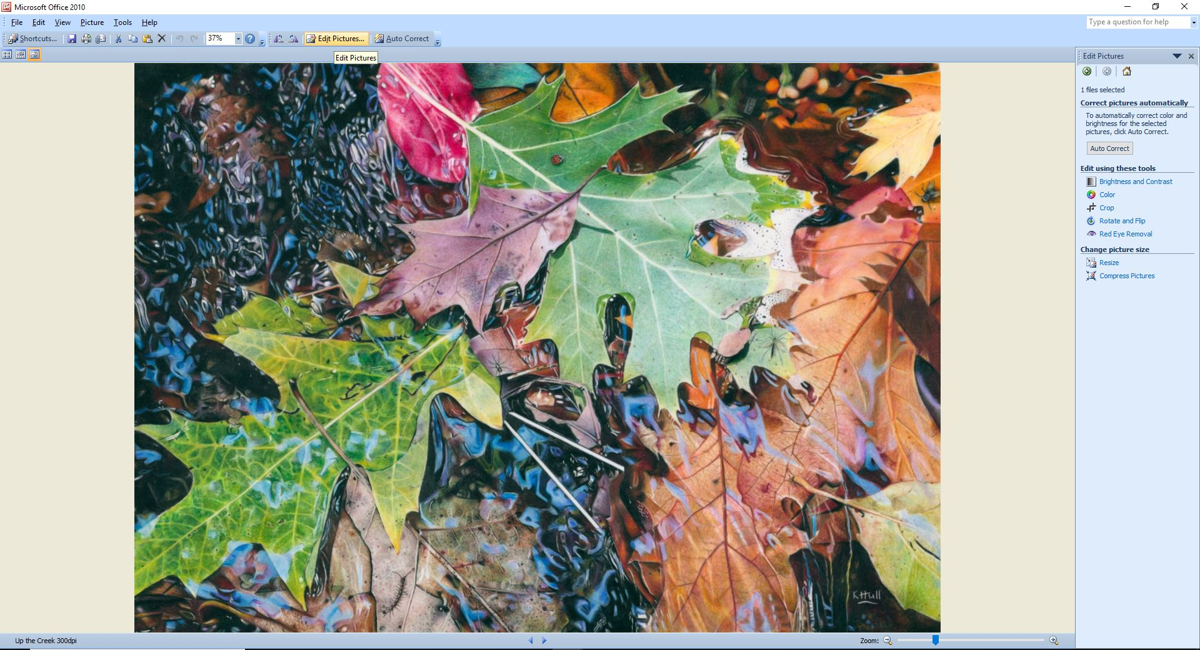
In Figure 4 I have zoomed in and cropped the above image so that you can better see where to click. Click on ‘Edit Pictures’.
Figure 3
Figure 4
Once you click on ‘Edit Pictures’ a menu will come up on the right-hand side of your screen as per the Figures 5 and 6. Just below the heading ‘Change Picture Size’, you will see an option to ‘Resize’ – click on this.
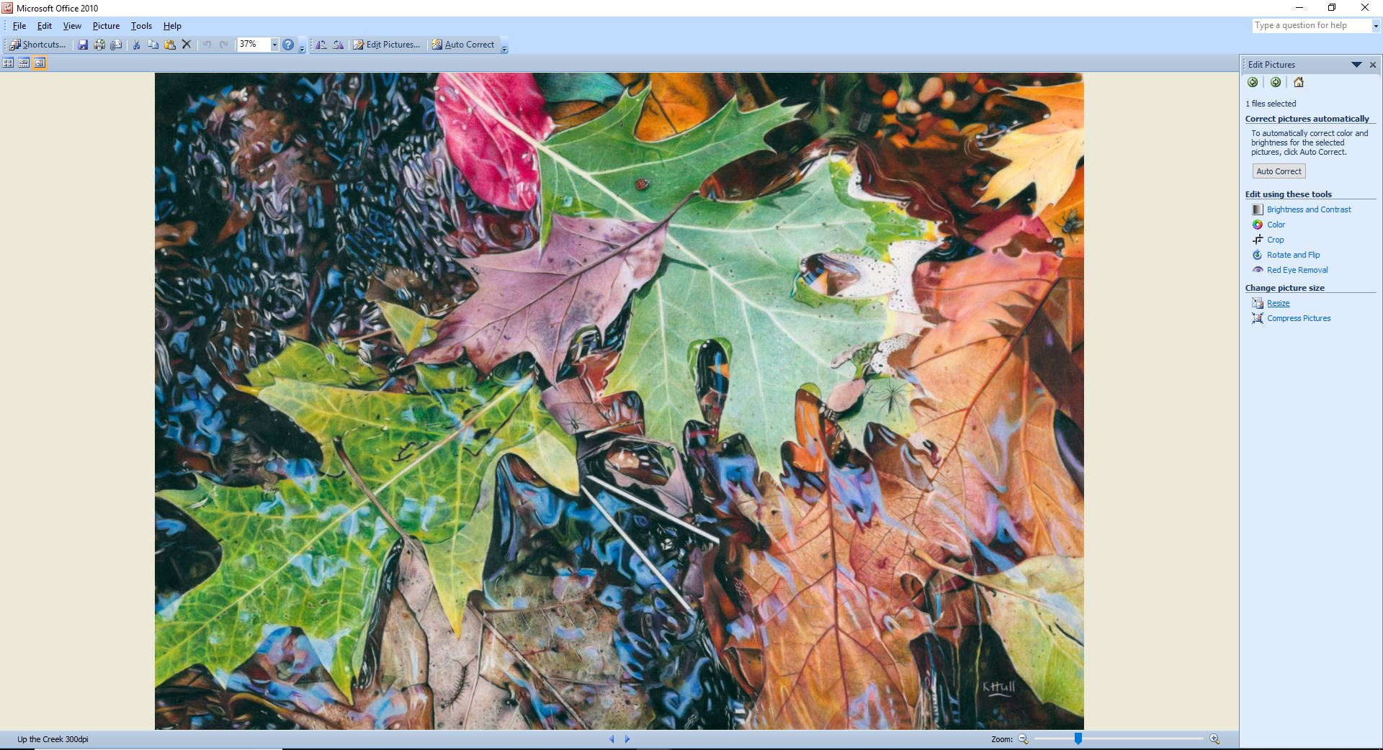
Figure 5

Of all the programs used in this PDF to resize images, I think the Microsoft Picture Manager is probably the least versatile and so would be my last choice to edit a picture but is a good option for anyone who doesn’t want to download any extra programs.
In most programs, we are given the option to change the pixel size along one side of an image and then it will maintain the image ratio, adjusting the pixels along the other side as well but this option doesn’t appear possible in Picture manager. The ‘Predefined width x height’ gives you a range of options predetermined by the app with set widths and heights. This could be a good option if you quickly want to resize your image and are not concerned about precise sizes or pixels. With ‘Custom width x height’, you need to know exactly which height and width you want to change your image to, so you might need to have a calculator handy if you want to keep the ratio of your image exact.
Figure 6
The easiest way to get the image close to what you might need (say for a required size in an exhibition) is to adjust the percentage of the original width x height. As you adjust the percentage (Arrow 3) up and down, keep an eye on the pixels shown by arrow 4 in the image below. I was trying to get the image as close to 1920 pixels on the longest side. The closest I could get it was 1921 pixels.
Once you are happy with the overall size of your image, click on ‘OK’.
Next, we need to save our newly sized image and the most important thing to remember at this stage is not to simply click Save otherwise you will overwrite your original image and lose the larger image.
Figure 7
NB: Always click on ‘Save as’ and not just ‘Save’ when saving a newly resized image so that you don’t overwrite the size of your original file.
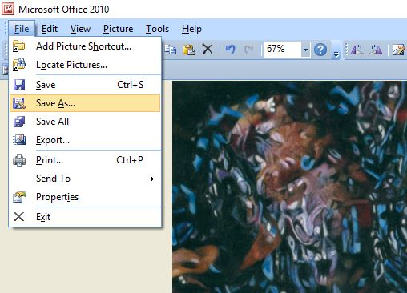
Figure 8
Go to the top left-hand corner, click on ‘File’, then click on ‘Save As’ and be sure to give your new image a different name to the original image. If the image is a specific size, I often put that in the file name, if it is for an exhibition or website, then add that so you can easily find it. For the CPCAU exhibition, you will need to add your first name followed by your surname eg KarenHull.jpeg
Figure 9 shows the original file name (you can also see within the folder all the different names I have given the various sized versions of this artwork)
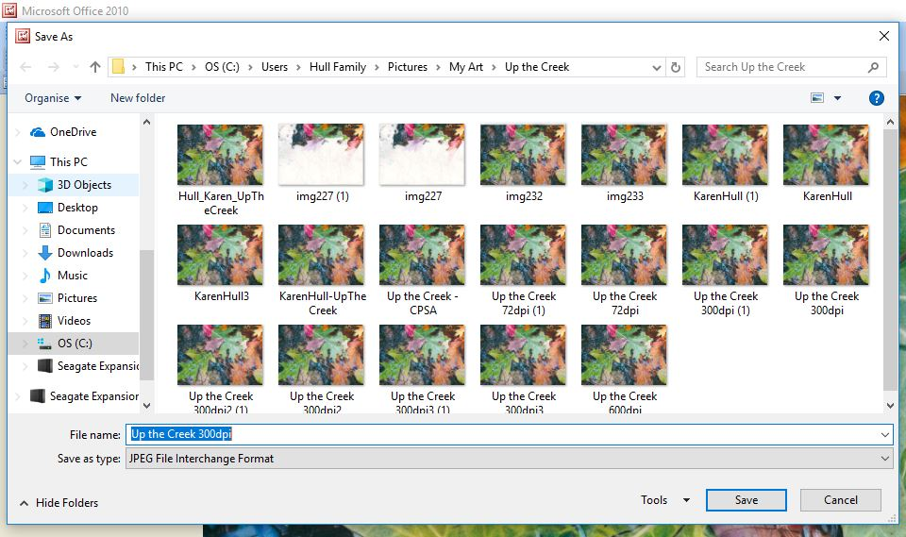
Figure 9
Figure 10 gives you an example of a file name so that you can easily find this particular sized image. Once you have added our new file name and located the folder you want to save your image, then click on ‘Save’.

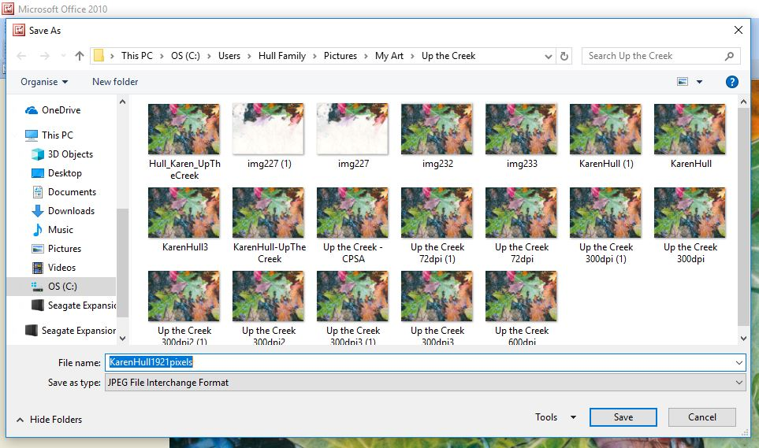
Figure 10

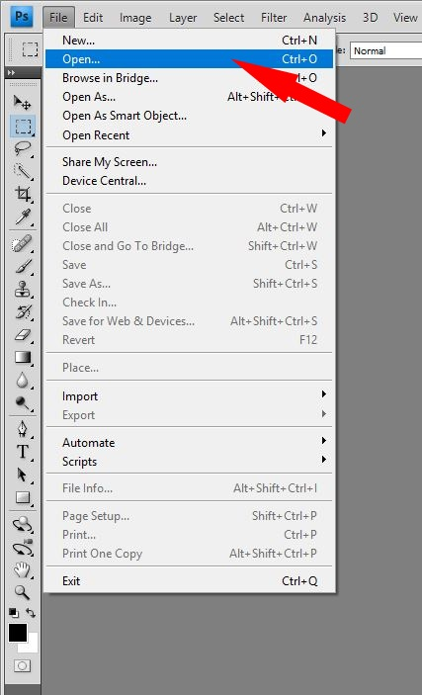
Figure 11
There are a couple of ways you can open your image in Photoshop. The first is to open the app on your desktop and then click on ‘File’ and from the drop-down menu, click on ‘Open’.
Once you do that you will be given the option to locate your image on your computer. I store all my images in folders under Pictures. Once you have found your image, click on it, and the file name will appear in the ‘File Name’ box and you then click on ‘Open’ (see figure 12).

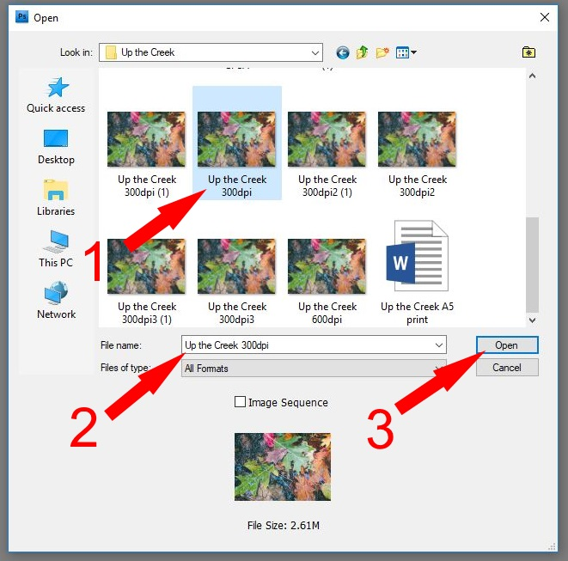
Figure 12
The second way you can open your image in Photoshop is to right click on the image as we did for the Microsoft Picture Manager and from the drop-down menu, click on ‘Open with’ and then ‘Adobe Photoshop’ (in whatever version you have – mine is a very old CS4) – see Figure 13
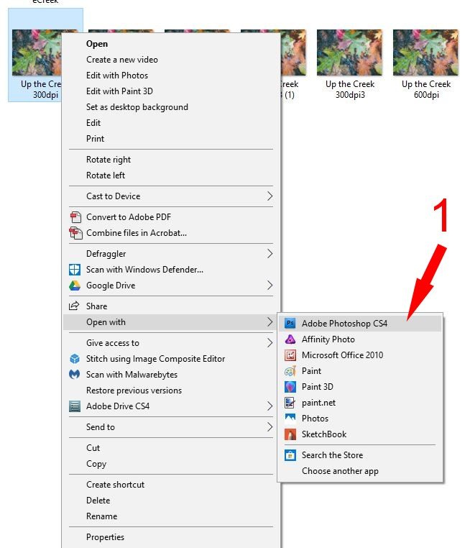
Figure 13
Once you have your image open, go to the menu along the top of the page, click on ‘Image’ and then from the menu select ‘Image Size’ (image 14). A box will then appear in the centre of your screen (image 15).
Figure 14

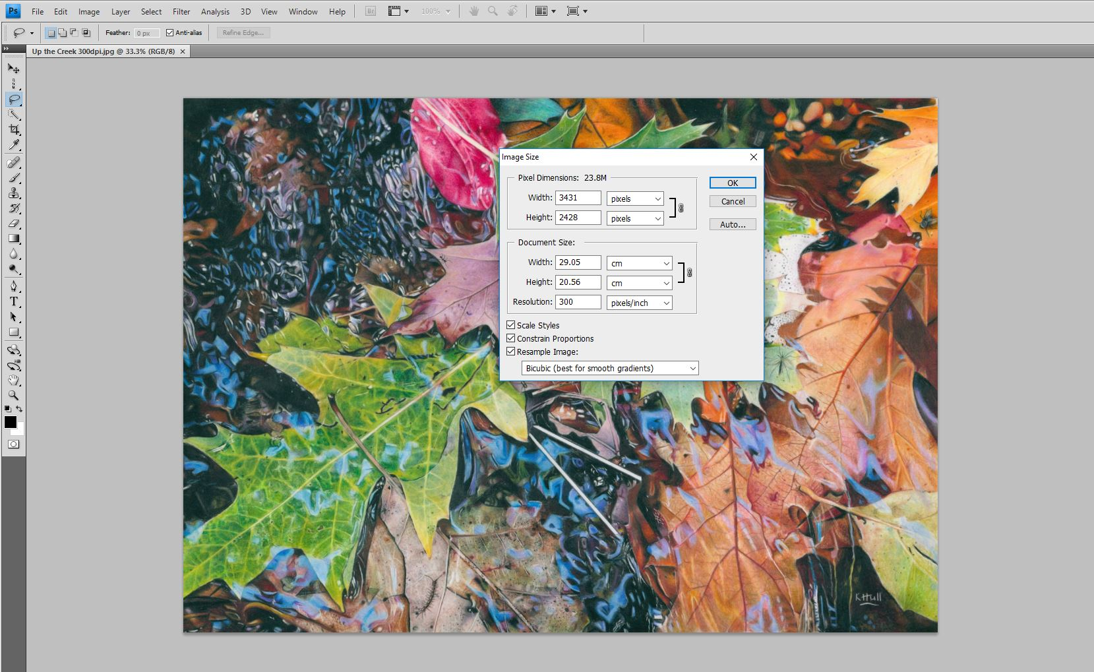
Figure 15
Figure 16

Figure 17

Image 15 shows the original size of the image at 3431 pixels by 2428. I changed the width to 1920 pixels (image 17) and you can see that Photoshop has adjusted the height as well so that the image proportions stay the same. If you find that the proportions have not been kept the same, then make sure that the ‘Constrain Proportions’ box has been checked. If this box is left unchecked, then your image may become distorted when you try to resize it.
The other thing you might need to look at, when adjusting the size of your image is the resolution. I save most of my images at 300 dpi (dpi stands for dots per inch, but what we are really referring to is the pixels per inch). Many exhibitions and online sites will ask for your images to be resized to 72 dpi and you can do this within the Resolution box.

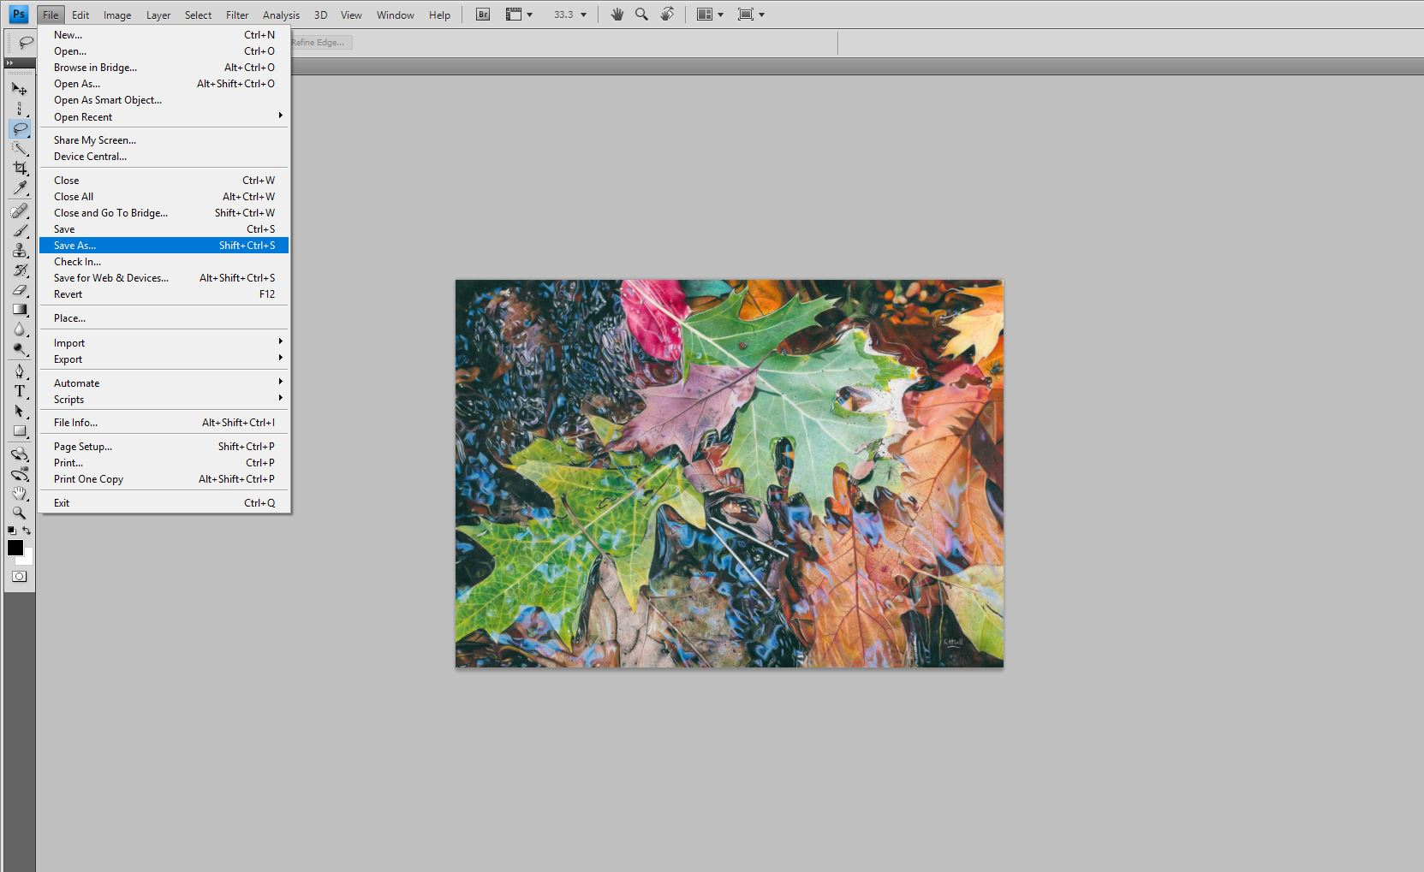
Figure 18
Once you are happy with the resizing of your image then go back to the top left-hand corner and click on ‘File’ and ‘Save as’ from the drop-down menu.
Figure 19

Once you click on ‘Save as’, a box will appear in the middle of your screen. You can either click on the File name and change the name of your new image of else click on the box beside Save As a Copy (figure 20). Mostly, I save my images as jpegs but there are a few reasons why you might save it in another file format. If you have a clear background behind your image that you need to preserve (such as around a logo), then you might want to save it as a .png which will keep the transparency of the background – saving it as a jpeg will automatically convert the background to white or whatever colour your background is preset to. You might also want to save it as a .psd file which is the file extension for a Photoshop file, and this will enable you to come and make amendments to any adjustments you have made to your image within Photoshop.
Figure 20

Artist Friend Jocelyn Brandow had another helpful tip when adjusting your pixel size in Photoshop:
Change the dpi of your image first using the methods described above, but if you also need to change your resolution, then you will want to keep the same dpi that you have just entered. In order to do that, you will need to uncheck the box that says ‘Resample Image’ so that your pixel sizes stay the same. Jocelyn kindly took some screen shots to help explain:
In the first screen shot we can see that the pixels are listed as 1500 for both width and height and the resolution is shown as 300 pixels/inch.
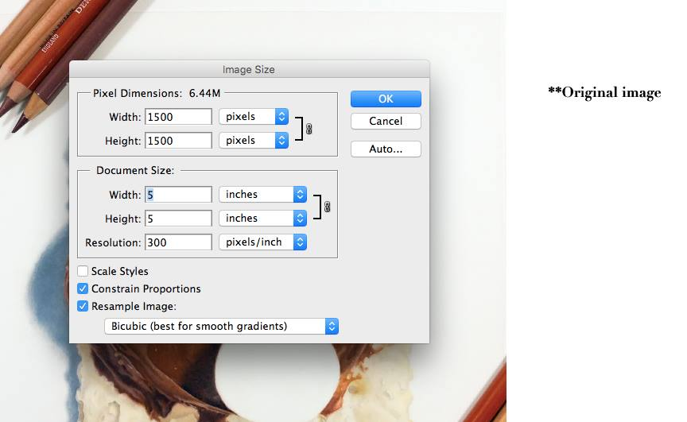
Screenshot 1
In screenshot 2, the resolution has been changed with the Resample box checked, and you can see that the pixel dimensions have also changed which isn’t what we want.
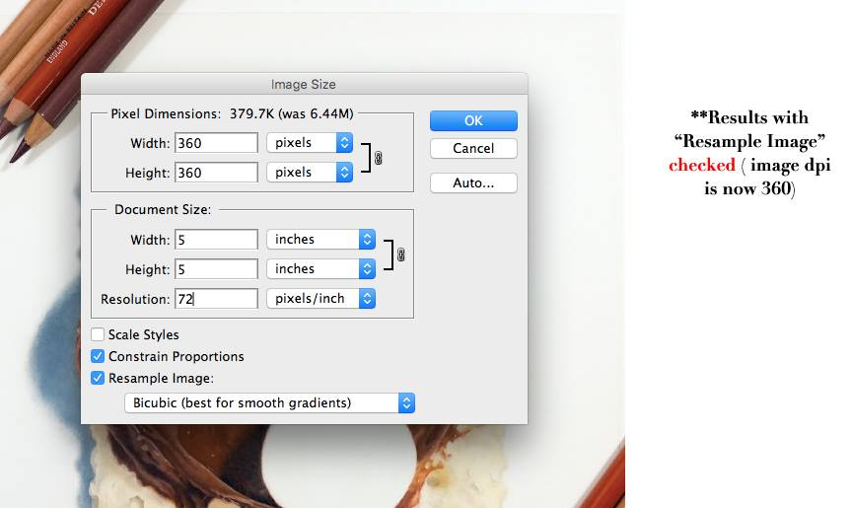
Screenshot 2
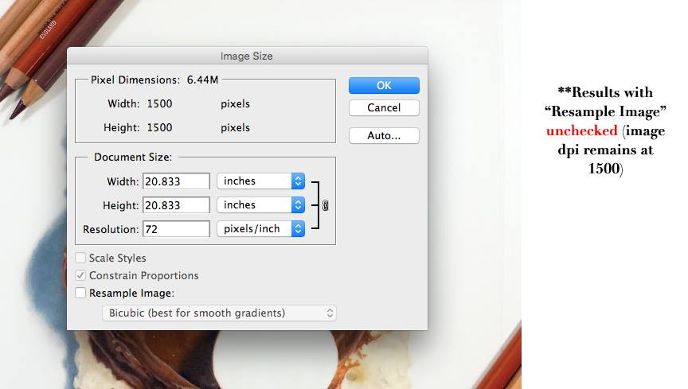
Screenshot 3
In screenshot 3, the Resample Image box has been left unchecked and you can see that the Pixel dimensions have stayed at 1500 on either side even though the resolution has been reduced to 72.
A big thanks to Jocelyn for this great tip!

Paint.net is my go-to app for making quick and simple edits to images. It is a free app however, at this stage is only available for use on Windows and not for a Mac. If you do a search in Google for Paint.net, you will actually be taken to a site that sells paint and so you need to go to the getpaint.net site to download this app. When you go to this site, you will see a page that looks like this:
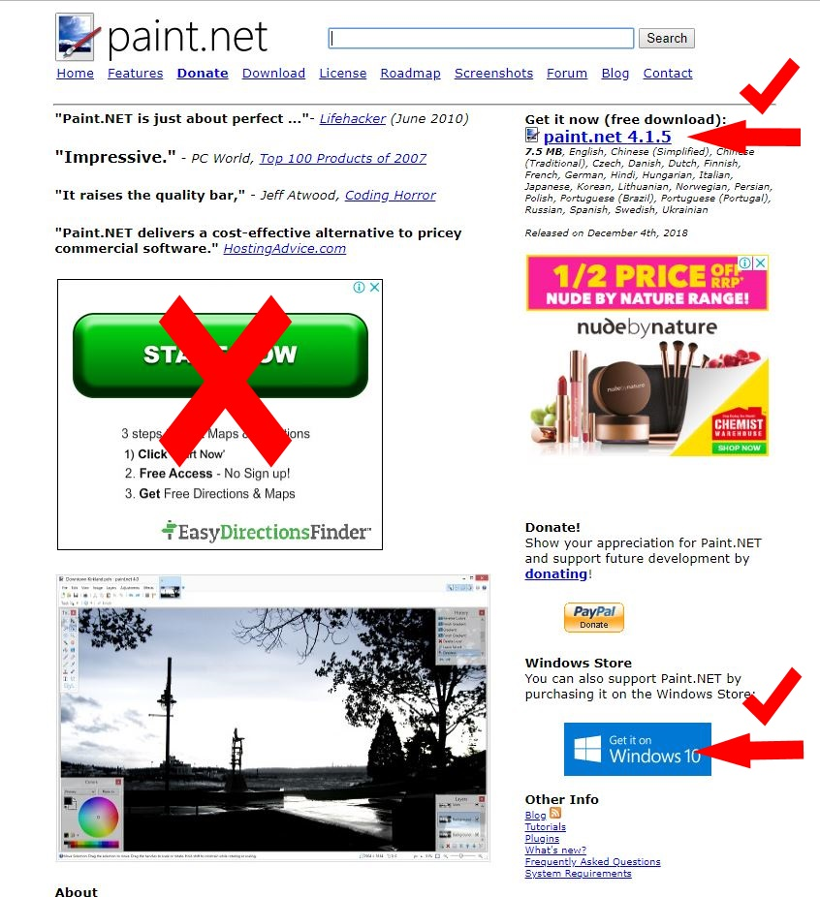
Figure 21
It is very important that you click on the right box to download the app so that you don’t inadvertently download any unwanted apps or spam ware. Click on the blue link Paint.Net shown in the top right-hand side of Figure 21. Alternatively, you can go to the Windows 10 store and download it from there.
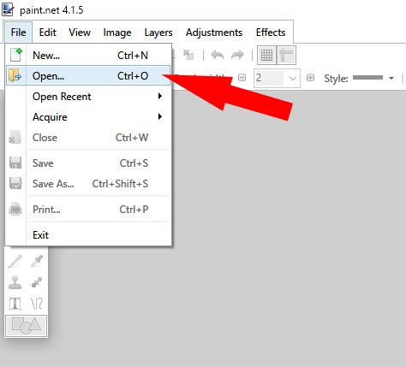
Figure 22
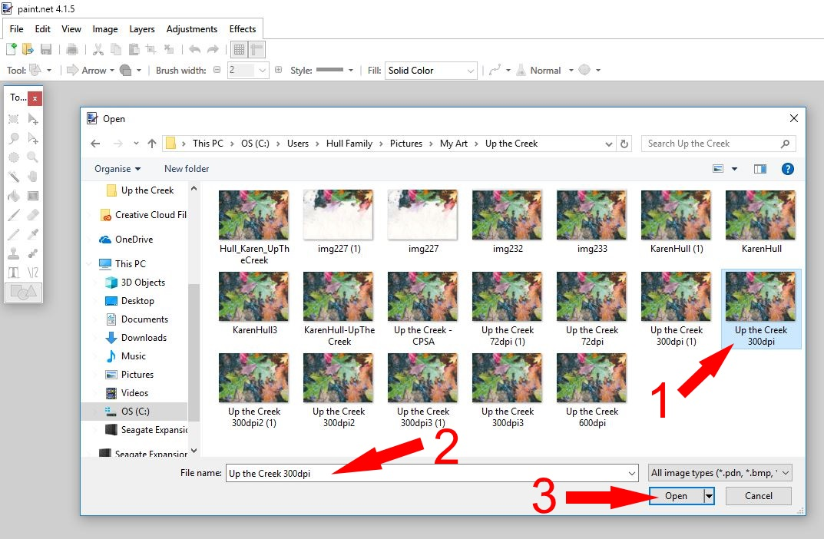
Figure 23
Once again, there are two ways you can open your image in the Paint.net app. The first is to open the app, click on ‘File’ and then ‘Open’ as per Figure 22. Locate your image on your computer, click on the image, check the File name to see you have the correct one and then click ‘Open’ Figure 23.
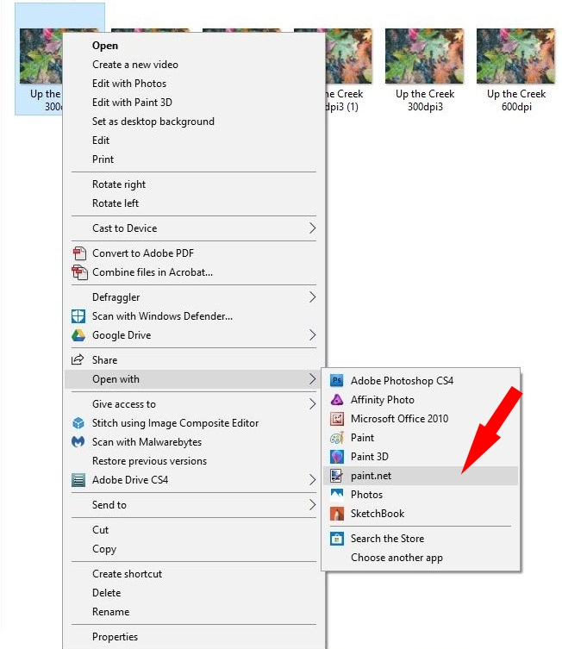
Figure 24
The other way is to once again right click on your image, go to ‘Open with’ and then click on ‘Paint.net’ Figure 24.

Once you open the image, you will see a screen that resembles Figure 25.
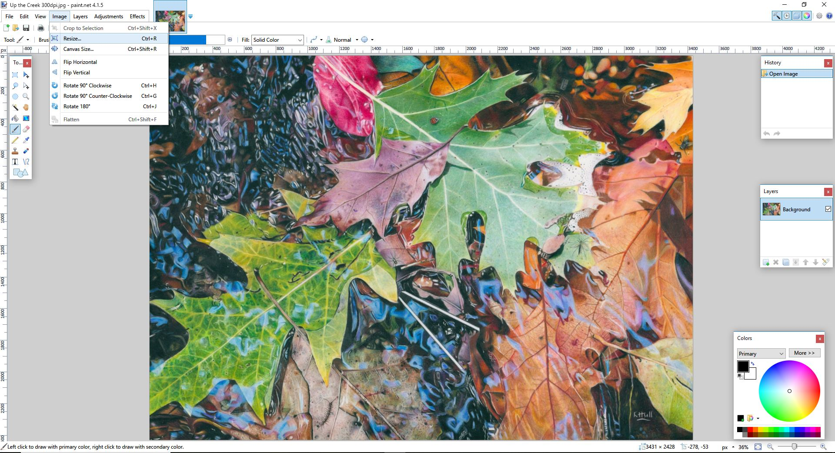
Figure 25

Figure 26
From the menu in the top left corner, click on ‘Image’ and then ‘Resize’ as per Figure 26.

Figure 27
Once you do that, a box will open in the middle of your screen as per Figure 27. If you need to do a quick resize of your image and aren’t worried about exact pixel measurements, then reducing your image by percentage is the quickest way to do this. If, however you need a more specific resize, then it is best to do the resize using ‘By absolute size’ and make sure that the ‘Maintain aspect ratio’ indicated by Aarrow 2 is checked so that your image proportions stay the same when you adjust the pixels of either the width or height.
Figure 28 shows how I reduced the Width to 1920 pixels and the Height was automatically adjusted for me. Most exhibitions will have a preferred size for the longest side of your image so always check that when adjusting your size.
You will also note that once again, I have this image saved at 300 pixels/inch and so, if your requirements are for an image set at 72dpi then you will need to make this adjustment in the Resolution box. Once you are happy with the overall size of your image, click ‘OK’.
Figure28

Figure 29
As with the other programs, once you are happy with the size of your image, click on ‘File’, then ‘Save as’ and give your resized image a new name.

Gimp is a free image editing program that will work on either Windows or a Mac and you can download it from https://www.gimp.org/. I prefer the user interface of Paint.net as it seems less complicated but GIMP appears to have a wider range of editing options.
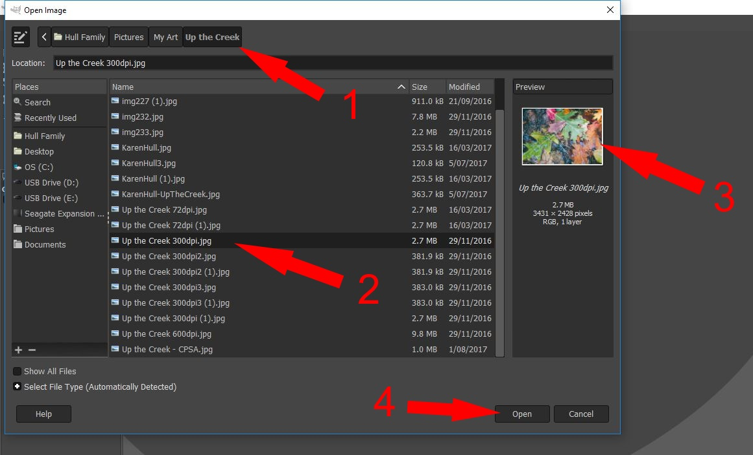
Figure 30
You will need to locate your image by click on the menu under Places on the left-hand side of the screen and you can see the path I followed to find my image with Arrow 1. You then scroll down the list of images until you find the one you need indicated by Arrow 2 - I prefer to see thumbnails, rather than image details when searching for an image however you are given a Preview window as per Arrow 3 when you search for your images on your computer. Once you are happy that you have the correct image then click on ‘Open’ and you will see your image open as per Figure 31.
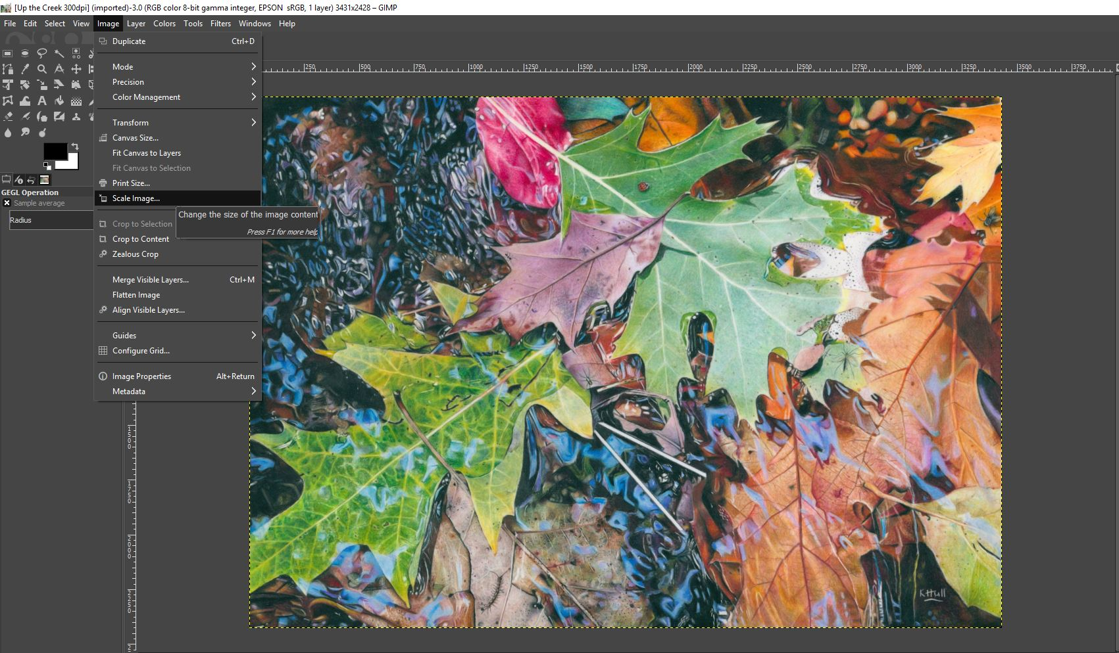
Figure 31
Figure 32 is a zoomed in crop of Figure 31. To resize your image in GIMP, click on ‘Image’ and then from the drop-down menu, click on ‘Scale Image’.
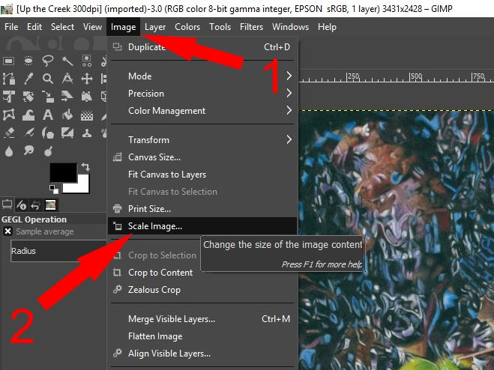
Figure 32
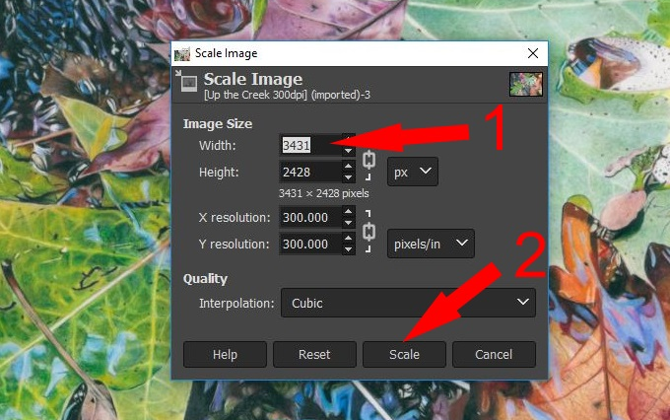
Figure 33
Once you do that the box shown in Figure 33 will open in the middle of your screen. You can adjust the number of pixels for either your Width or Height but, unlike a couple of the other apps, you will not see the other length adjust automatically. You will need to click on Scale as indicated by Arrow 2 and then both Width and Height will be in proportion. Figure 34 shows you how the box should look after you have clicked ‘Scale’
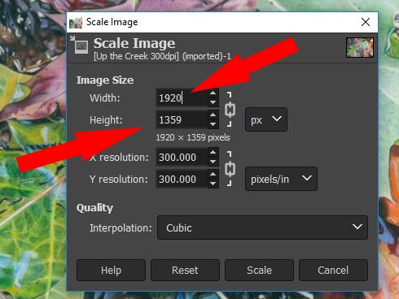
Figure 34
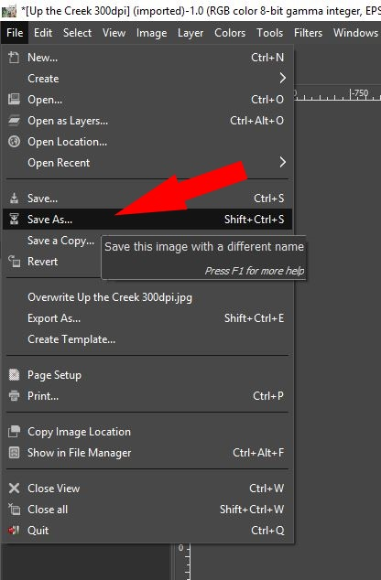
Figure 35
Once you are happy with your image, click on ‘File’, then ‘Save as’ and give your image a new name.

Preparing Your Images
This next section deals with ensuring that your images are suitable for submission when entering them into an online exhibition.
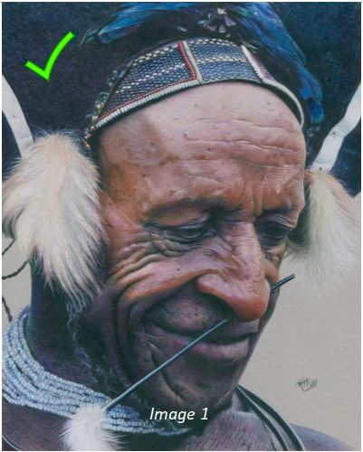 | When preparing your artworks and images for an exhibition, it is so important to present them professionally.  Image 1 is an example of a digital image that meets all the necessary requirements for most online exhibitions. It is a clear, high quality scan with no unworked areas showing.
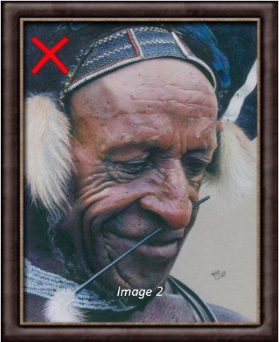 | Image 2 is not an ideal image because the frame is showing. It is best to scan or photograph your images prior to putting them in a frame, however if this isn’t possible then you should crop your image so that the frame is no longer visible.
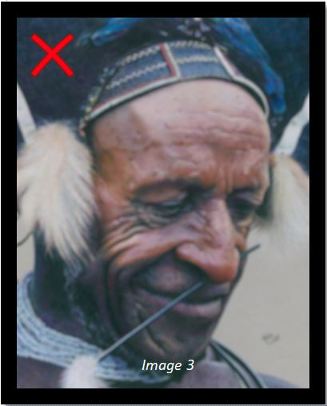 | Before submitting your images, check to see that the photographs or scans you are planning to enter are nice and clear. Image 3 shows an example of a digital image that could be rejected from an online exhibition because it is blurry and impossible for the judge to make out any detail in the artwork.  It is advisable not to add any digital frames to your artworks prior to submitting them.
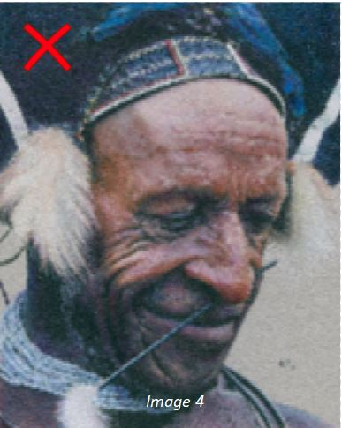 |  | Image 4 is an example of an image that has been reduced too much and pixilation has occurred. Once again, it would be impossible for a judge to determine the quality of this artwork based on the image provided.  Before submitting your digital image, check the required size and resolution specifications.
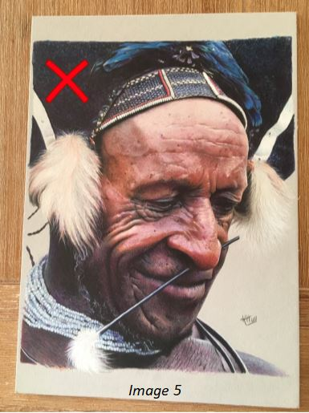 |  | Believe it or not, Image 5 is the kind of image that does get submitted for inclusion in online galleries and exhibitions. It is imperative that, if you are going to take a photo of your artwork, that the image is square on so that there is no distortion or skewing of your image and the outside border must be cropped so that all we can see is the artwork.
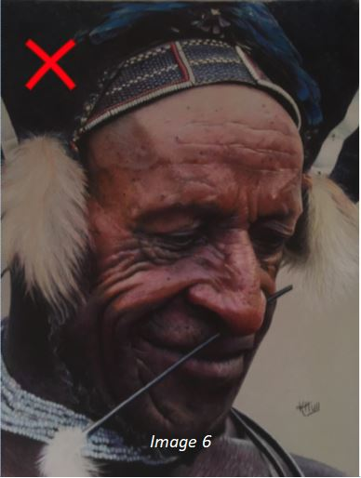 |  | In Image 6 we find an example of an artwork where the photograph is under exposed and slightly blurry. If photographing your work, try to do it under natural light, where the lighting that falls on your picture is even with no glare or shadows forming. Be sure to focus on the artwork prior to taking the picture so that you get a nice, clear image.

